CApital one Financial corporation, New York City, NY
Feb 07- July 08, Business Data Analyst
Environment: SQL loader, MS Visio, MS Project, TOAD Manager, Quick Test Pro 8.2, Bugzilla, Oracle 9i, Softek TDMF Technology, Business Objects XI R2, Essbase 5/6, Hyperion.

Capital One Financial Corporation, through its subsidiaries, provides various financial products and services to consumers, small businesses, and commercial clients. The company offers commercial and consumer loans, commercial and consumer deposit account services, commercial credit cards, treasury management services, trust services, and other banking related products, such as insurance, brokerage services, merchant services, and investment banking, as well as provides money market and certificate of deposit accounts through Internet channels. The project involved setting up of direct deposit of the Payroll Department for Capital One’s clients, this involved setting up of ACH gateway. Our team was also responsible for design of SSH functionality using batch processes for data transfer from various systems and SSH for remote monitoring and management of servers for copying files from local server to remote host.

Responsibilities:

- Managed requirements from system users and preparation of business requirement documents using Rational Requisite Pro that provided appropriate scope of work for technical team to develop prototype and overall system.
- Created UML based diagrams using Rational Rose and MS-Visio for Use Cases and Activity Diagrams, for better understanding of the layout of the new process.
- Gathered the functional and business requirements by conducting JAD sessions and participatory Design Sessions involving major leads from the Technical Department.
- Used SSH for remote monitoring and management of servers for copying files from local server to remote host
- Performed data conversion, stratification and quality control testing of interim and final data and preparation of all reports and data transmissions to client for projects
- Extracted data from Oracle into temporary tables in order to cleanup and standardize column entries for re-import into new Oracle data structures. Used extensive ad-hoc queries to create/modify/delete data
- Responsible for researching and writing functional specification documents for custom Lotus Notes database projects for Capital One ACH (CIF, 2 new databases).
- Worked extensively on Static, ad hoc, automated and dynamic Hyperion Essbase reporting.
- Developed a Hyperion Essbase reporting solution to facilitate a more efficient ways of reporting process.
- Gathered requirements and participated in database design and development as well as report design and development, testing plan co-development and quality assurance.
- Generated Executive Problem Management Reports in excel with Essbase.
- Extracted data from Oracle into temporary tables in order to cleanup and standardize column entries for re-import into new Oracle data structures. Used extensive ad-hoc queries to create/modify/delete data.
- Oversaw the implementation of Encryption Gateway Server of Managed File Transfer platform supported via protocols like PM4Data, SFTP, Connect Direct Desktop, and SSL VPN Max infrastructure.

Tell me about your experience with Wholesale products, specifically Treasury Management Services?
At Capital One, I was the primary BA responsible for setting up tools for Capital One’s commercial customers. I worked on an application that helped Capital One’s customers to set up direct deposit of Payroll through ACH for Capital One customers’ employees.

What is NACHA?

This is an Electronic payment association, which oversees the ACH network a safe, efficient, green, and high-quality payment system. NACHA is responsible for the administration, development, and enforcement of the NACHA Operating Rules and sound risk management practices for the ACH Network. Through its industry councils and forums, NACHA brings together hundreds of payments system stakeholder organizations to encourage the efficient utilization of the ACH Network and develop new ways to use the Network to benefit its diverse set of participants. NACHA represents nearly 11,000 financial institutions through direct membership and 18 regional payments associations. NACHA and its members provide education, tools, and resources to increase the adoption of ACH payments to benefit businesses, consumers, and governments.

What exactly NACHA does?
Rule Making
NACHA provides the legal foundation for the ACH Network through the development and enforcement of the The NACHA Operating Rules. Rules and guidelines are established for all participants in the ACH system and ensure that the Network infrastructure, applications, rules and enforcement are consistent with processing payments in a secure, reliable, and efficient manner, and that financial institutions have access to effective risk management tools.
Education
NACHA educates its direct members, the regional payments associations, and the public through a diverse offering of conferences, workshops, teleconferences, and publications. Topics covered include ACH fundamentals, Rules updates, risk management, global payments, electronic check, electronic billing and payment, and more. NACHA also offers the Accredited ACH Professional (AAP) program exam each October to individuals seeking industry credentials.
New Payments Applications
NACHA develops new payments applications through an open and disciplined process that measures the impact on all Network participants, including originators and receivers, and is responsive to the priorities of depository financial institutions.
Risk Management
NACHA develops and implements a comprehensive risk management framework for the Network that covers requirements prior to origination, ongoing origination requirements, and enforcement, and ACH Operator risk mitigation services. NACHA also works to create and implement a robust set of risk management tools to reduce risk and improve ACH quality that are consistent with the risk management framework.
Member Communications
NACHA promotes and consistently communicates the value and best uses of electronic payments to depository financial institutions and their customers through marketing, public relations, and education. Additionally, NACHA broadly engages key external audiences to communicate the value proposition of the Network and ACH Payments.
Marketing
NACHA actively promotes the value and use of electronic payments through educational materials, events, speaking engagements, advertising, and television and radio promotions. Additionally, NACHA coordinates the annual Direct Deposit and Direct Payment (May) national campaign, highlighting the benefits of Direct Deposit for payroll, pension, and Social security payments.
Regulatory and Government Relations Issues
NACHA establishes and maintains formal relationships with key industry audiences, including the Federal Reserve System and the U.S. Department of the Treasury and responds expeditiously to regulatory and government relations issues.

What is PGP, how does it work? Where did you use it?
PGP is an encryption algorithm, stands for Pretty Good Privacy. This was invented by Philip Zimmerman in 1991. In this every user has two keys to encrypt and decrypt. There is one Public and the other one is a secret key. The public key is sent out to the client or the clients use your public key to encrypt the message. The secret key is used to decrypt the message, either the message sent by the client or your own message. Usage of PGP.
- Create a directory for PGP:
For example,
cd
mkdir .pgp

- Set the environment variable PGPPATH to point to this directory:
If you are using csh, do the following:
setenv PGPPATH $HOME/.pgp
- Generate your private and public keys:
pgp -kg

For example:
John Q. Public

When you are asked for a pass phrase, type in a good pass phrase. You can use
pwcheck -h math

to check if your pass phrase is not easy to guess. You will be asked to type in some random text.
You need to go through this process just once.
- Encrypting documents:
Once you have generated your keys, you can encrypt a file yourfile by simply typing:
pgp -e yourfile

When you are prompted with:
A user ID is required to select the recipient's public key.
Enter the recipient's user ID:

Type in the user ID you chose during the key generation process. (e.g: jqpublic@UWATERLOO.CA) The encrypted file will then be created with the name yourfile.pgp. You do not need to use a pass phrase for every document you encrypt. You can now remove the original yourfile.
- Decrypting documents:
To decrypt yourfile.pgp, type
pgp yourfile.pgp

When you are prompted for a pass phrase, type in the personal pass phrase you chose during key generation.
As mentioned before, PGP provides many other facilities such as provision of e-mail privacy. For more detailed information do:
man pgp
Even more detailed documentation can be found in the files:
/software/pgp/doc/pgpdoc1.txt.Z
/software/pgp/doc/pgpdoc2.txt.Z
You can use the zmore command to read this documentation

Where did I Use it?

This type of file transfer was generally used for internal purpose and for client reporting. We used it when we had to transfer the files of the employees having their information about their account number, SSN Number, Credit history, Checking and saving outstanding, Tax reports and other.
On the request from the internal departments or from the client enrolled with direct deposit, the files were transmitted using PGP encryption.

What is PKI?

Public Key infrastructures is a set of hardware, software, people need to manage, create, store, and distribute and revoke digital software. This is an arrangement which binds public keys with their respective user identities by means of CA (Certificate Authority). This has to be unique for every user. The registration authority helps in biding the confidentiality pertaining to the users public key. A PKI is an arrangement that binds public keys with respective user identities by means of a certificate authority (CA).
The alternative approach to the problem of public authentication of public key information is
- Web of trust: The best approach in a PGP type for web of trust is that it can incorporate with a PKI CA fully trusted by all parties in a domain that is willing to guarantee certificate.
- SPKI: Simple Public Key Infrastructure. The SPKI specification defines an authorization certificate format, providing for the delineation of privileges, rights or other such attributes (called authorizations) and binding them to a public key.

As a Business analyst, we also developed the Direct deposit payroll cost calculator
The purpose of this calculator is to provide a tool to use in calculating the costs of converting to Direct Deposit of payroll rather than writing payroll checks.

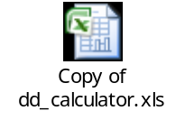

How to set up a ACH payment gateway?

From Clients perspective!!!!!!!!!!!

How to set up an ACH transmission with Capital One, these are the preliminary steps which have to be followed:

- Identify your ACH originator. In this case it is going to be Capital One (US banks can provide this feature)
- Choose either CCD Format ( Cash concentration or Disbursement) or CTX file format ( Corporate trade exchange) in this case for Capital one we abide by the CCD format
After the above process the testing and certification process follow up, upon that the banks and the clients are able to transact money using the ACH method.

This electronic payment method is regulated by NACHA (National Automated Clearing House Association).

- When determining which ACH format method suits your company’s needs several factors should be considered implementation, technical components, cost and convenience.
- For payroll format banks and Capital one generally uses the PPD format which is similar to the CCD format
- If the clients already use EDI (electronic Data Exchange) they can remit the money using the ACH/CTX format.

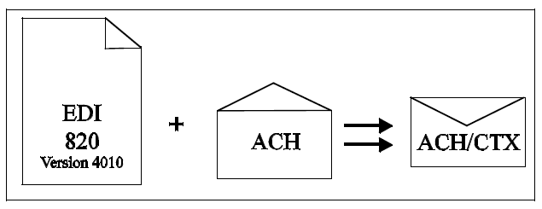

ACH SET UP, TESTING AND CERTIFICATION PROCESS FLOW

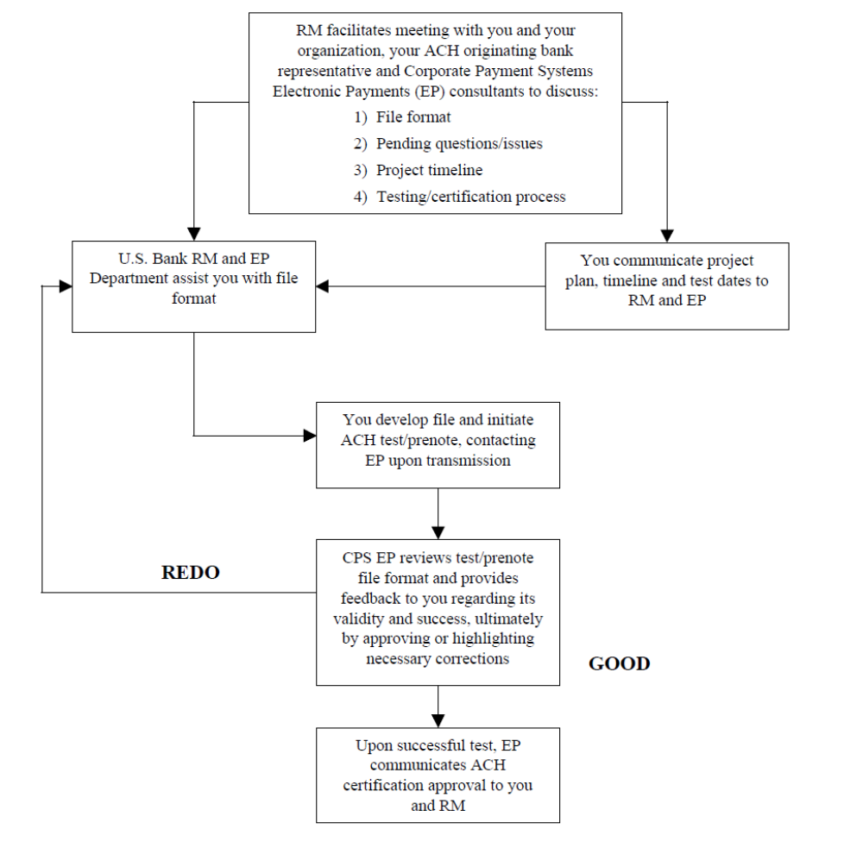

ACH PAYMENT PROCESS FLOW

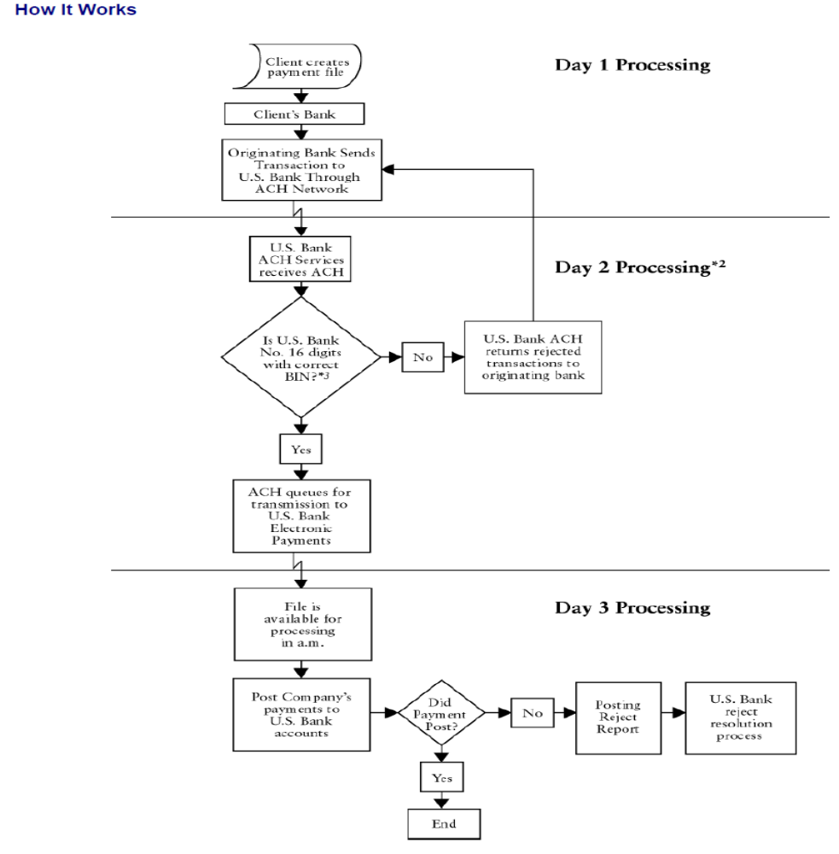
What is CCD Format?

This is a straight forward format and is easy to use. It provides opportunity to include remittance data using detail record. The detail record covers US banks 16 digit and type of payment code. It is required that the format CCD follows the NACHA format

Formatting Highlights:

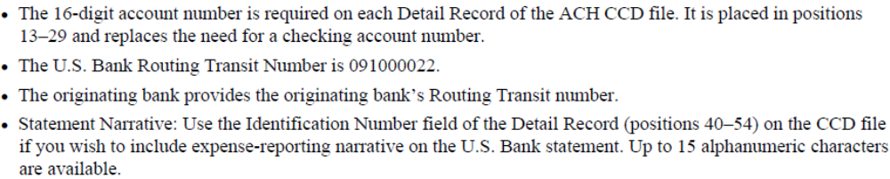

ACH CCD Diagram

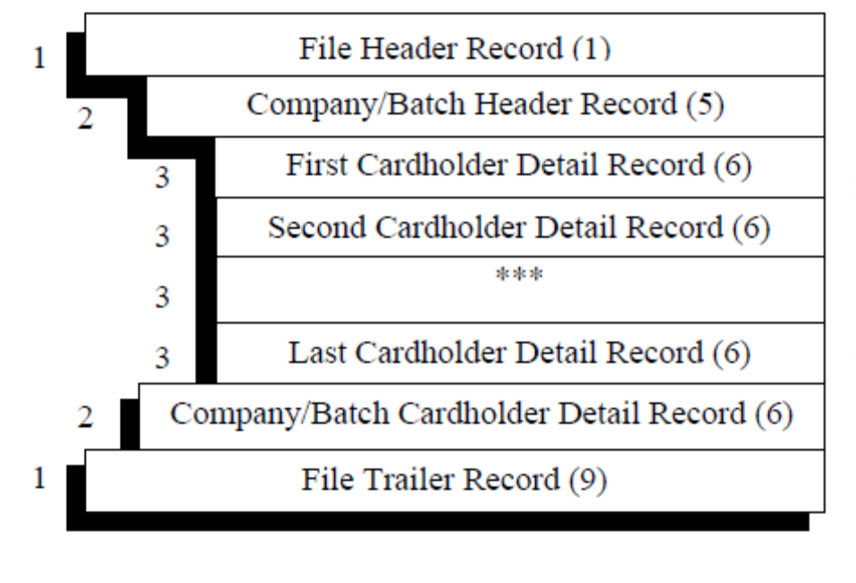

ACH CCD SAMPLE FILE FORMAT
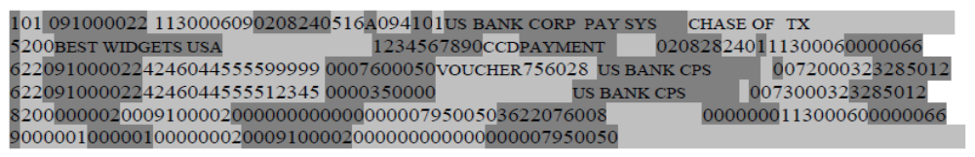
ACH FILE SPECIFICATION:
The following is the specification format for payroll department where the company creates a direct link

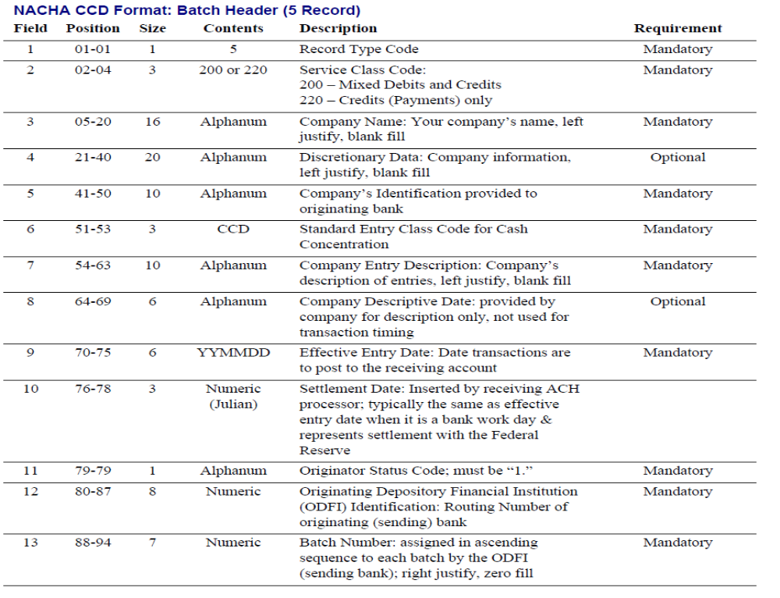

For companies using EDI they can remit using the CTX format

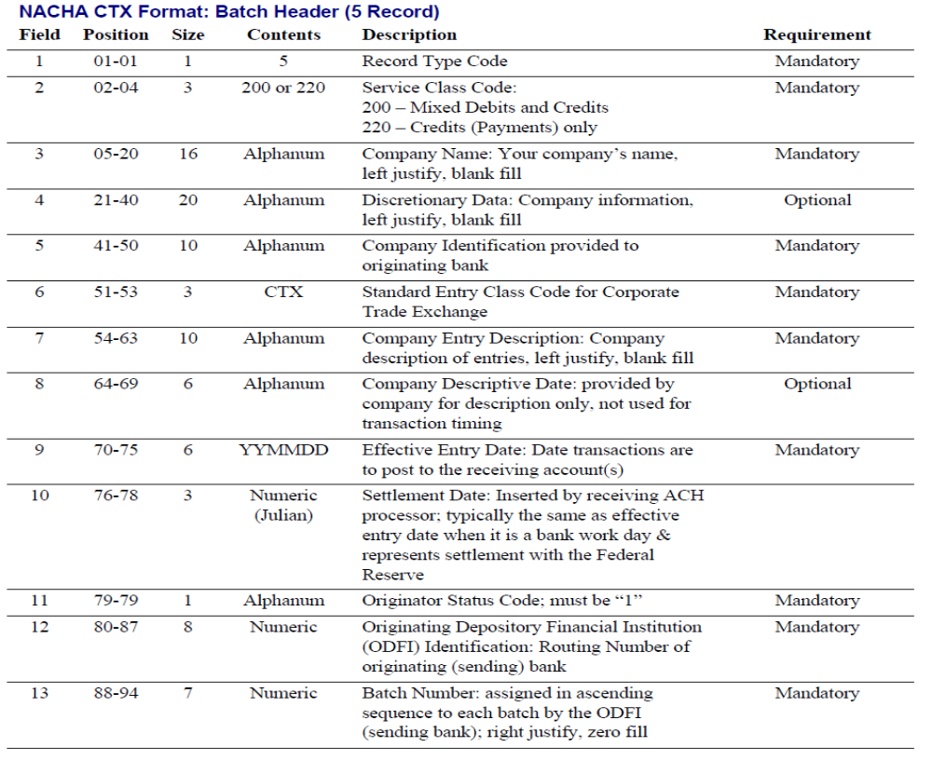

The Data transfer schedule for during the project

Employee Bankers 1
Employee
Bankers 2
Employee
Bankers..N!
Local Server

This server contains the information of the client’s i.e. companies which hook up their payroll with Capital One
sFTP over SSH Network
Clients i.e. Company 1
sFTP over SSH Network
sFTP over SSH Network
Clients i.e.
Company 2

Clients i.e.
Company …..N!
REMOTE HOST

Stores the information of the bankers account number, address, SSN and other details this server stores the information of all the employees bank accounts and the money they receive from the direct deposit i.e. payroll Dept of their company

